**Project Documentations**

**CookBook: Your Virtual Kitchen Assistant**

**1. Introduction**

**• CookBook: Your Virtual Kitchen Assistant**

**• Team ID :**  NM2025TMID46846

**• Team Leader**: L.M.Dharshinishree & dharshinishree0110@gmail.com

**• Team Members:**

|  |  |  |
| --- | --- | --- |
| **S.No** | **Name** | **Email ID** |
| **1.** | Gopika K | karthikeyanramasamy9787@gmail.com |
| **2.** | Giritha V | giritha2007@gmail.com |
| **3.** | Deepa N | deepaparvathi567@gmail.com |
| **4.** | Anupriya D | danupriya2006@gmail.com |

**2. Project Overview**

**• Purpose:**

SB Works connects clients and freelancers through project postings, bidding, and real-time communication.

**• Features**:

– Project posting and bidding

– Secure chat system

– Feedback and review system

– Admin control panel

**3. Architecture**

• **Frontend**:

React.js with Bootstrap and Material UI

• **Backend**:

Node.js and Express.js managing server logic and API endpoints

• **Database**:

MongoDB stores user data, project information, applications, and chat messages

**4. Setup Instructions**

**• Prerequisites**:

– Node.js

– MongoDB

– Git – React.js

– Express.js

– Mongoose

– Visual Studio Code

• **Installation Steps:**

# Clone the repository git clone

# Install client dependencies cd client npm install

# Install server dependencies cd

../server npm install

**5. Folder Structure**

SB-Works/

|-- client/ # React frontend

|__components/

L__ pages/

|__ server/ # Node.js backend

|__routes/

|__ models/

|__ controllers/

**6. Running the Application**

**• Frontend:**

cd client

npm start

**• Backend:**

cd server npm

start

• **Access**: Visit <http://localhost:3000>

**7. API Documentation**

• **User**:

– /api/user/register

– /api/user/login

• **Projects**:

– /api/projects/create

– /api/projects/:id

• **Applications**:

-- /api/apply

• **Chats**:

– /api/chat/send

– /api/chat/:userId

**8. Authentication**

• JWT-based authentication for secure login

• Middleware protects private routes

**9. User Interface**

• Landing Page

• Freelancer Dashboard

• Admin Panel

• Project Details Page

**10. Testing**

• Manual testing during milestones

• **Tools**: Postman, Chrome Dev

**11. Screenshots or Demo**

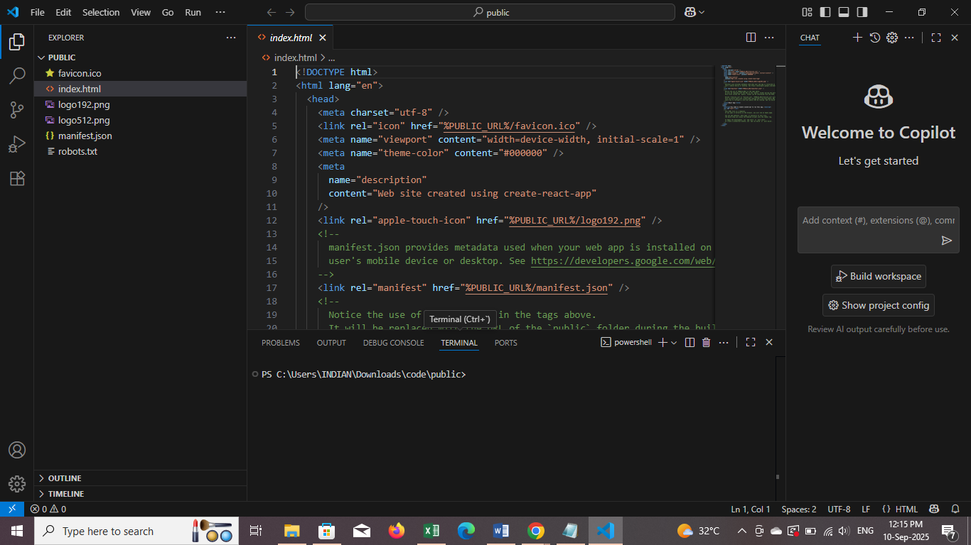

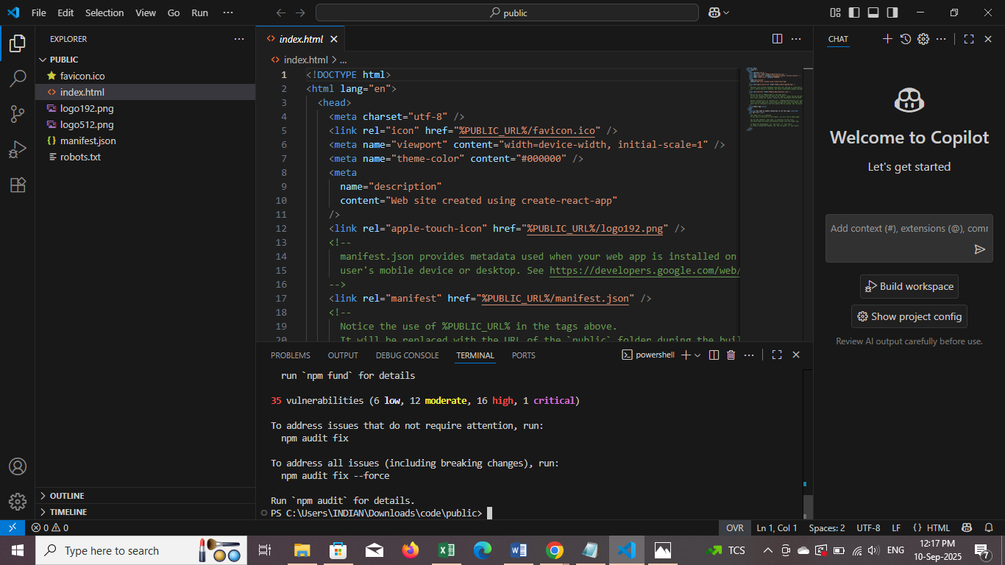

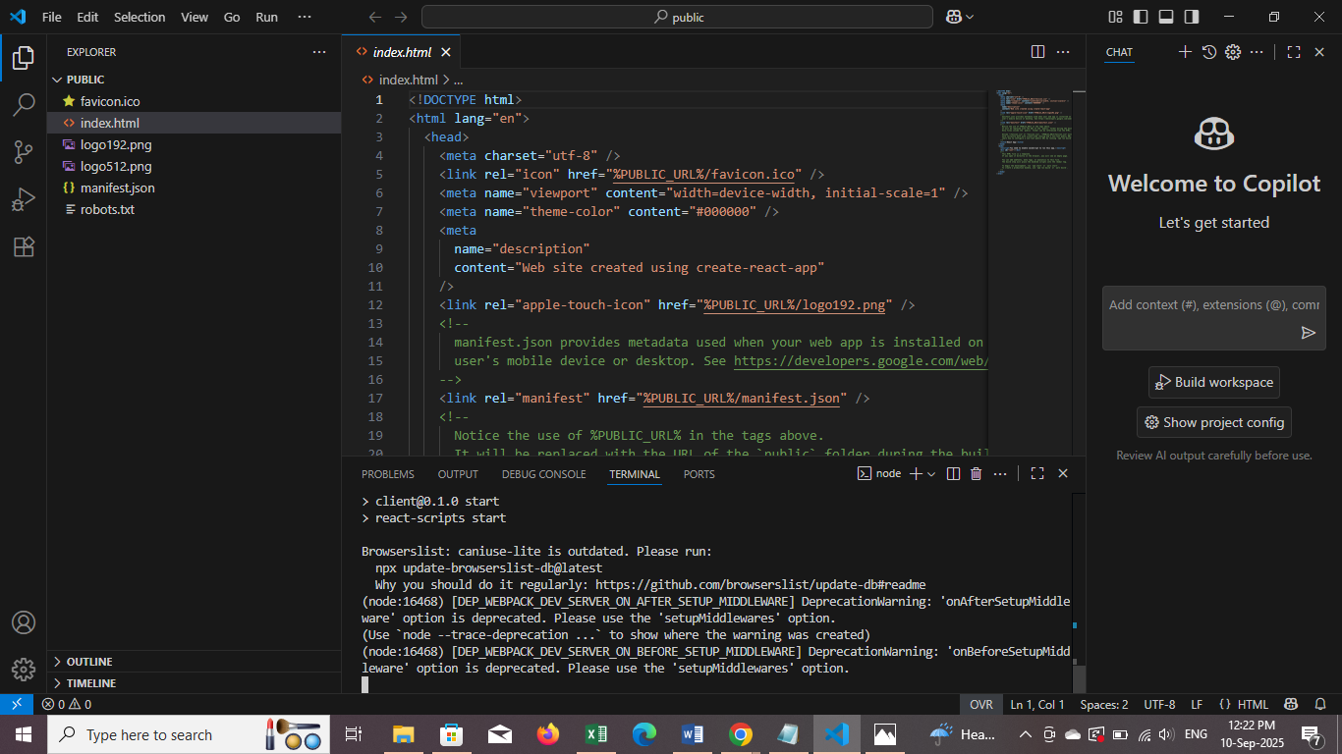

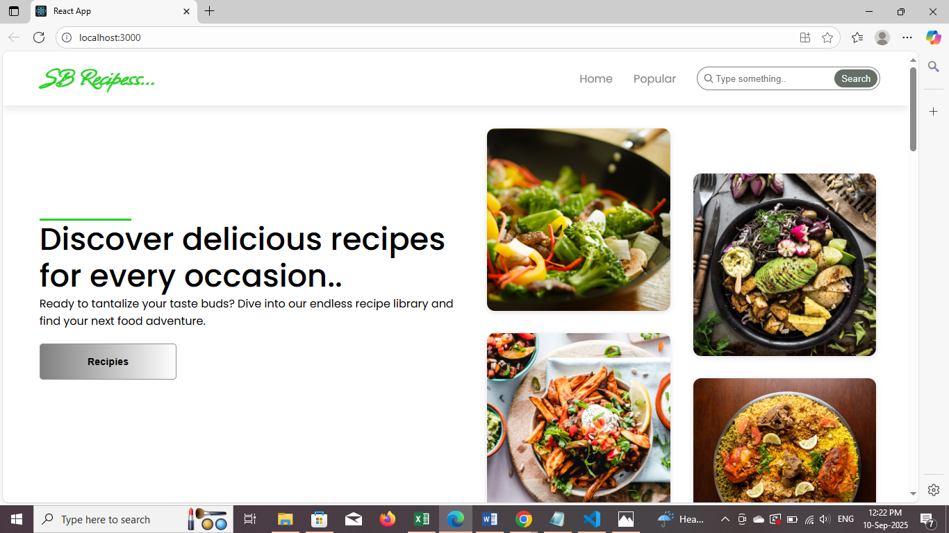

**12. Known Issues**

1. Meal planning and organization

2. Finding recipes based on dietary restrictions or preferences

3. Generating grocery lists

4. Step-by-step cooking instructions

5. Reducing food waste

6. Discovering new recipes

**13. Future Enhancements**

**Features**

1. Personalized recipe suggestions: Based on dietary preferences, cooking history, and nutritional needs.

2. Smart meal planning: Automatically generates meal plans based on seasonal ingredients, sales, and dietary needs.

3. Voice assistant integration: Allows users to interact with the app hands-free while cooking.

4. Recipe customization: Enables users to modify recipes based on ingredient availability, dietary needs, and personal preferences.

5. Social sharing: Allows users to share favorite recipes and cooking experiences with friends and family.

**Technical Enhancements**

1. Image recognition: Enables the app to recognize ingredients, dishes, and cooking techniques.

2. Machine learning: Improves recipe suggestions and meal planning based on user behaviour and preferences.

3. Integration with smart kitchen devices: Enables seamless control of kitchen appliances and gadgets.